JUnit Testing Exercises

**Exercise 1: Setting Up Junit**

**Scenario:** You need to set up JUnit in your Java project to start writing unit tests.

**CODE**:

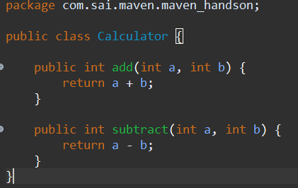

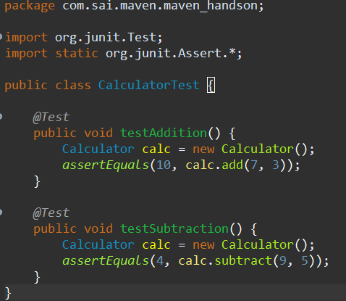

**OUTPUT:**

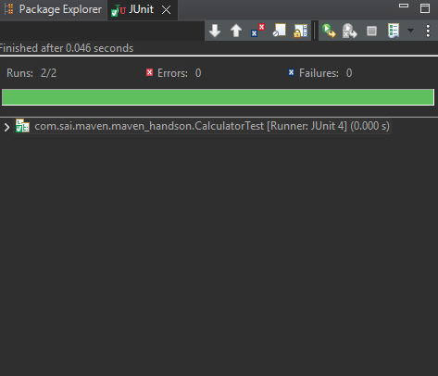

**Exercise 3: Assertions in Junit**

**Scenario:** You need to use different assertions in JUnit to validate your test results.

**CODE:**

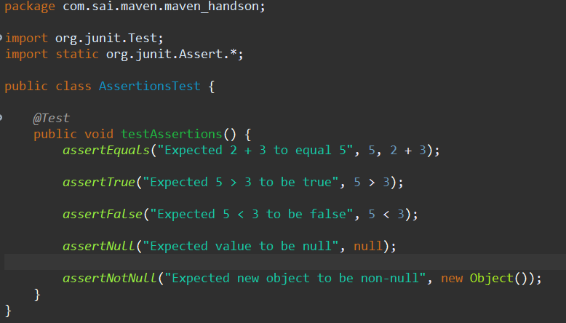

**OUTPUT:**

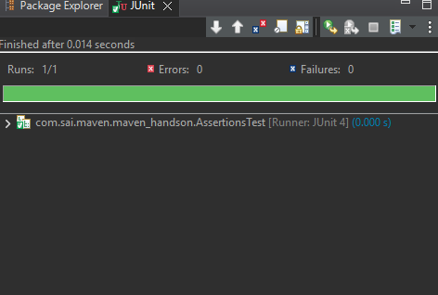

**Exercise 4: Arrange-Act-Assert (AAA) Pattern, Test Fixtures, Setup and Teardown Methods in Junit**

**Scenario**: You need to organize your tests using the Arrange-Act-Assert (AAA) pattern and use setup and teardown methods.

**CODE:**

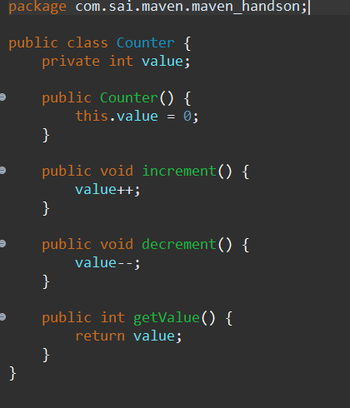

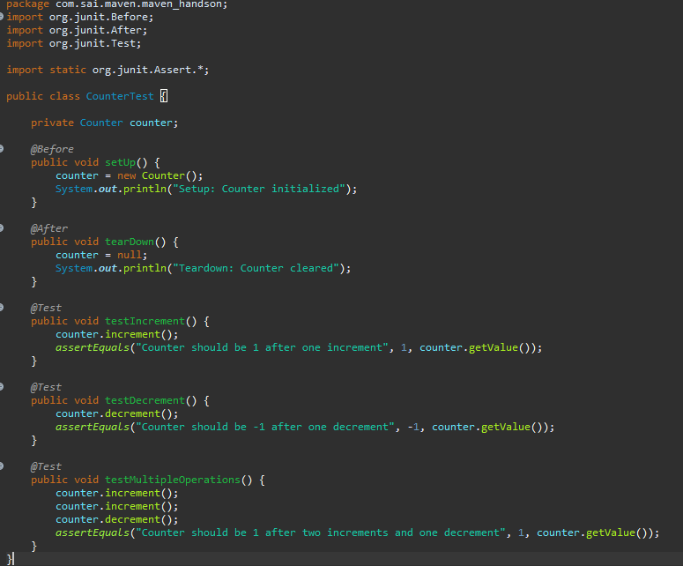

**OUTPUT:**

